Adding year as a linear effect to the first winter survival changed the results quite a bit.

Hind is now only marginally significant, and adults are now slightly more significant than hinds.

while year is not always significant:
Yellow = significant

 | With birth weight |  | Without birth weight
 | Density | Deer Year | Density | Deer Year
Hinds | -0.325 (p=0.093) | -0.005 (p=0.72) | -0.325 (p=0.080) | -0.006 (p=0.70)
Adults | -0.372 (p=0.065) | -0.034 (p=0.027) | -0.372 (p=0.054) | -0.034 (p=0.021)
Total | -0.194 (p=0.49) | -0.024 (p=0.54) | -0.192 (p=0.23) | -0.025 (p=0.072)
LU_total | -0.280 (p=0.19) | -0.031 (p=0.052) | -0.278 (p=0.17) | -0.031 (p=0.043)

Compared to the models without additional year effect
 | With birth weight  Density | Without birth weight  Density
Hinds | -0.36 (p=0.029) | -0.36 (p=0.023)
Adults | -0.14 (p=0.44) | -0.14 (p=0.42)
Total | -0.078 (p=0.66) | -0.075 (p=0.66)
LU_total | -0.043 (p=0.81) | -0.041 (p=0.81)
Models:
Hinds with Year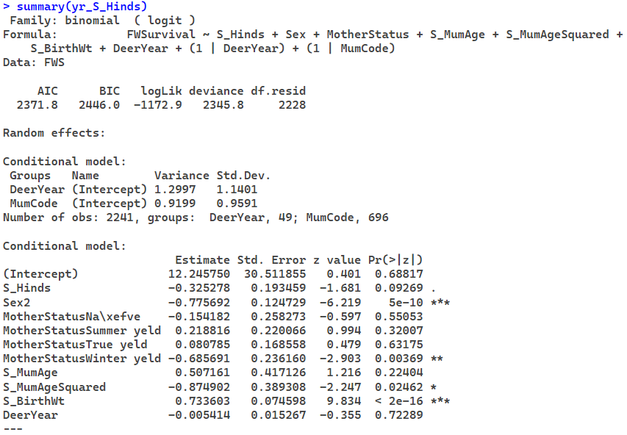
Adults with Year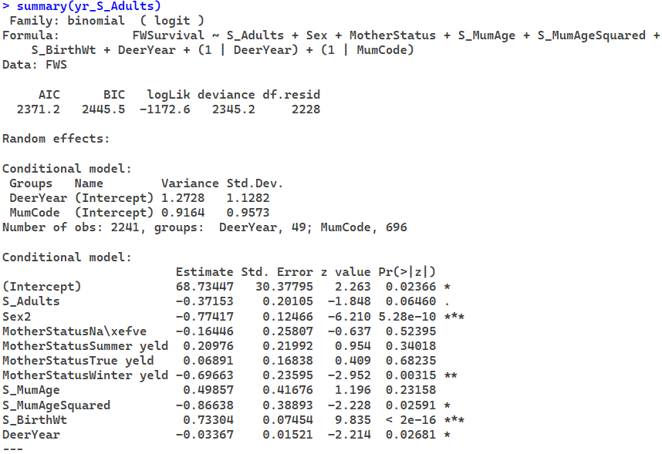
Total with Year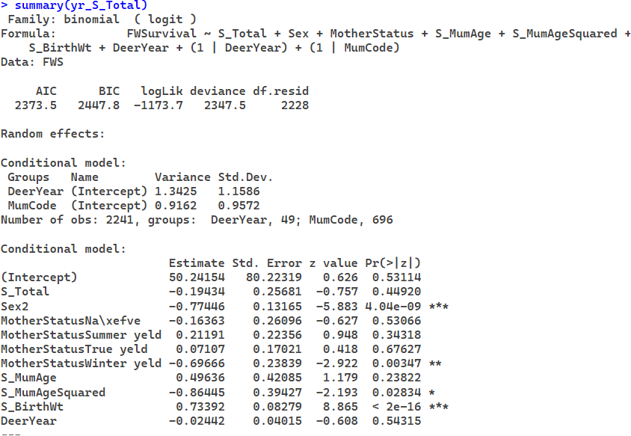
Livestock units with Year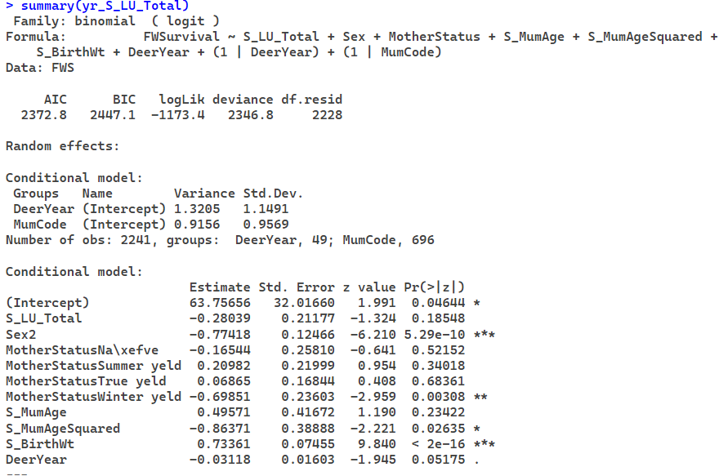

Hinds with Year without birth weight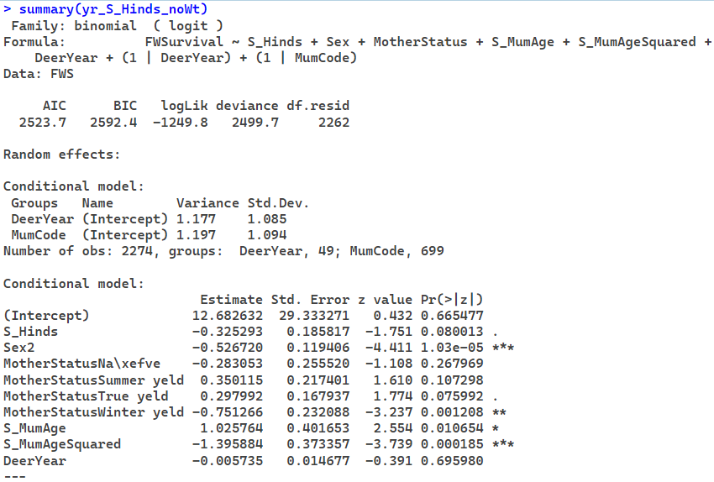
Adults with Year without birth weight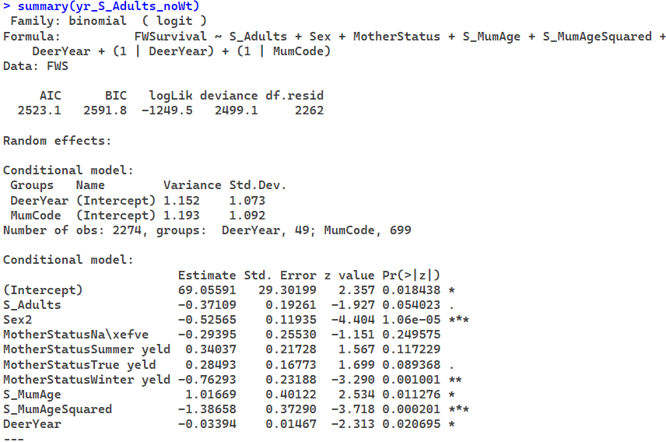
Total with Year without birth weight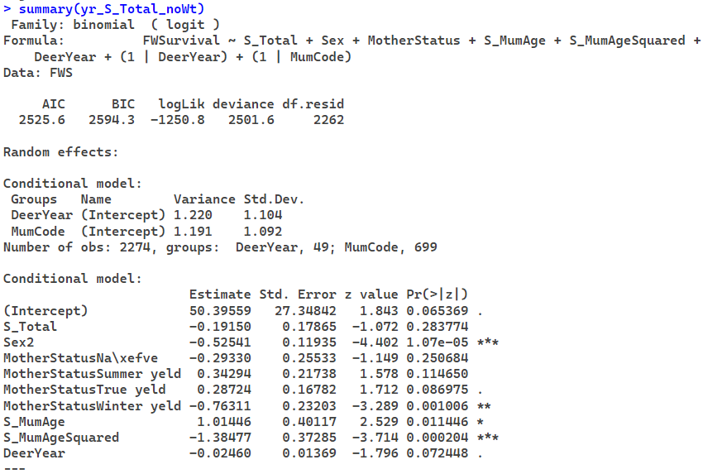
Livestock units with Year without birth weight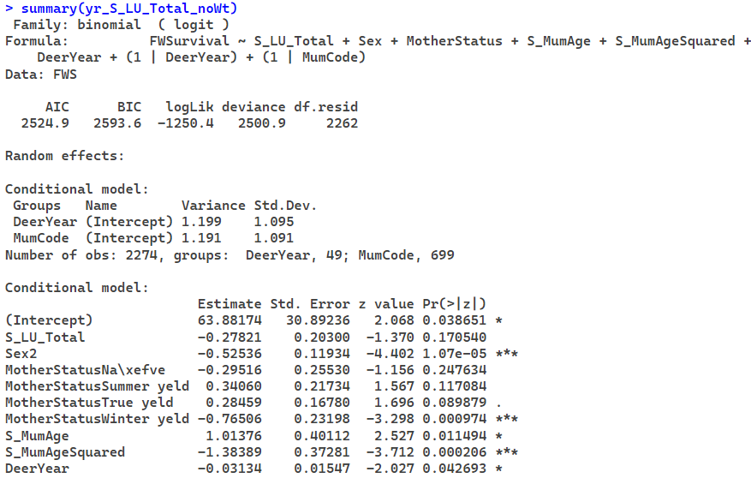

Hinds without Year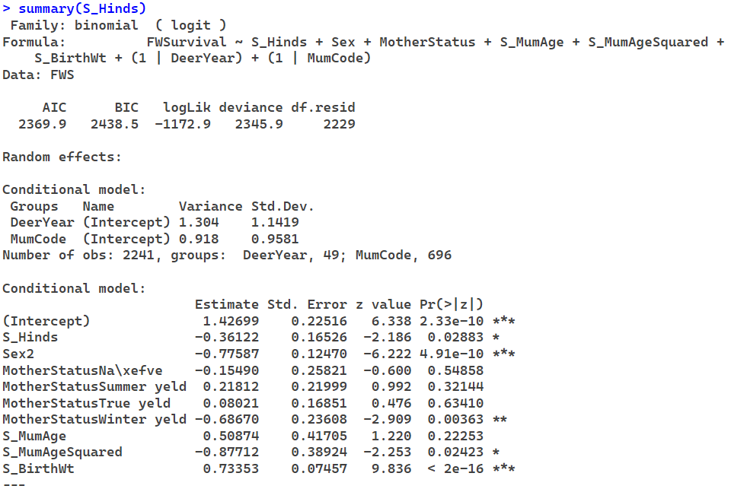

Adults without Year
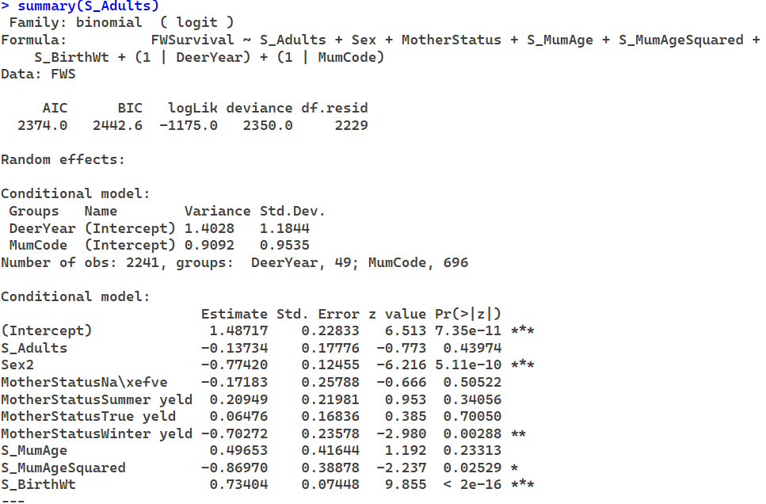

Total without Year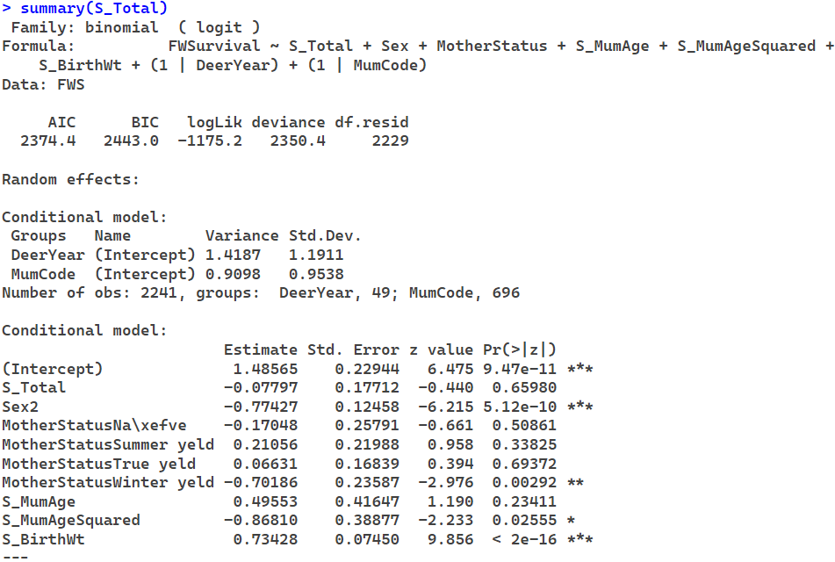

Livestock Units without Year
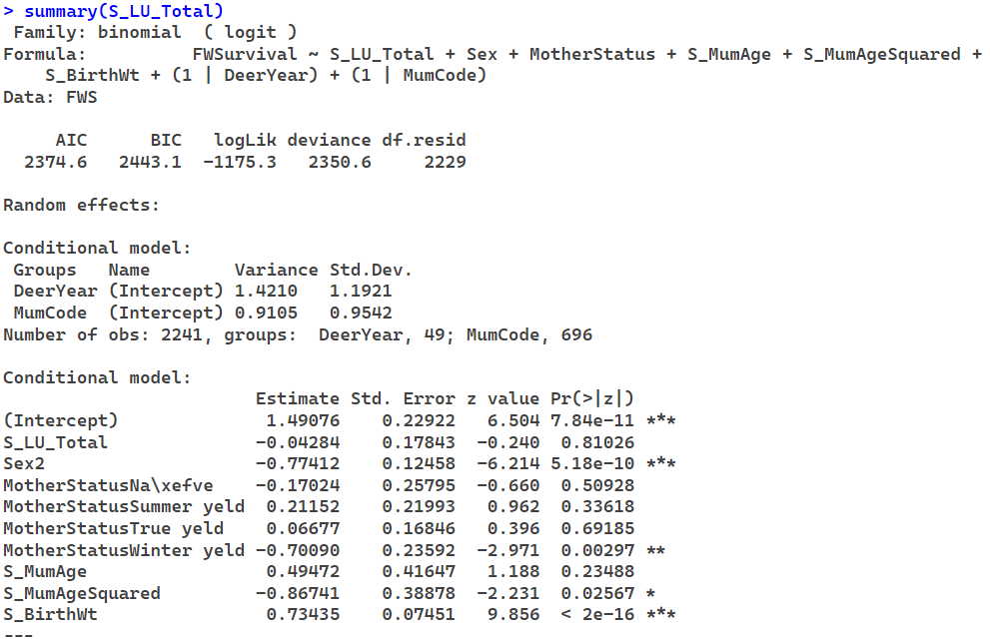

Hinds without Year & birth weight 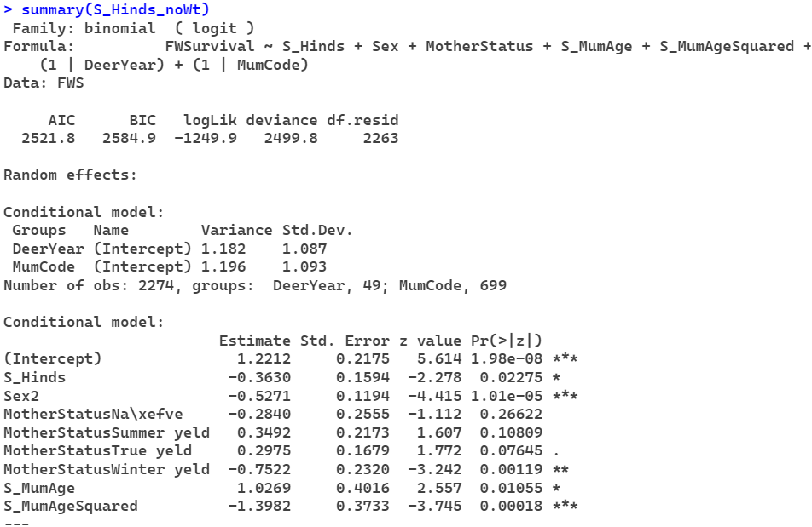

Adults without Year & birth weight
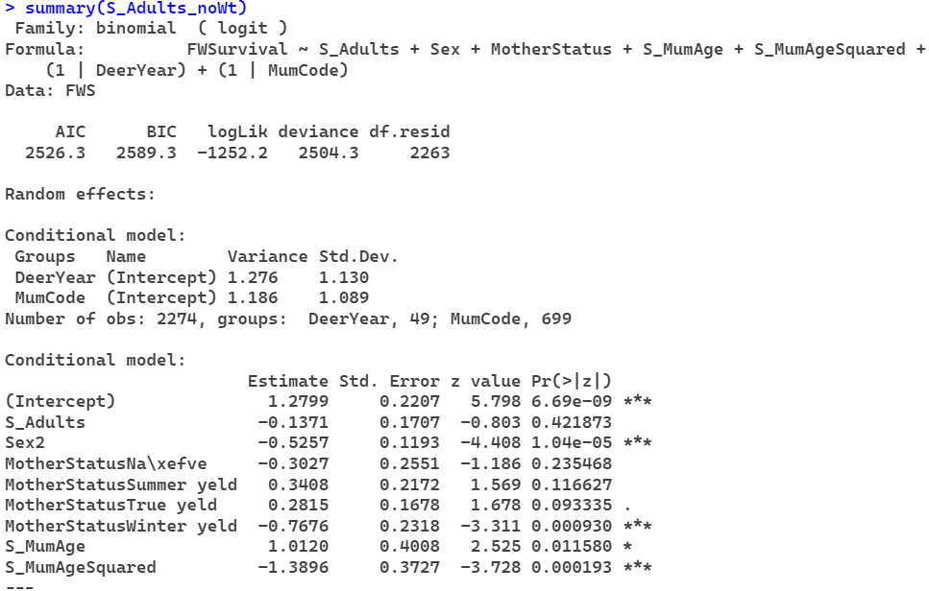

Total without Year & birth weight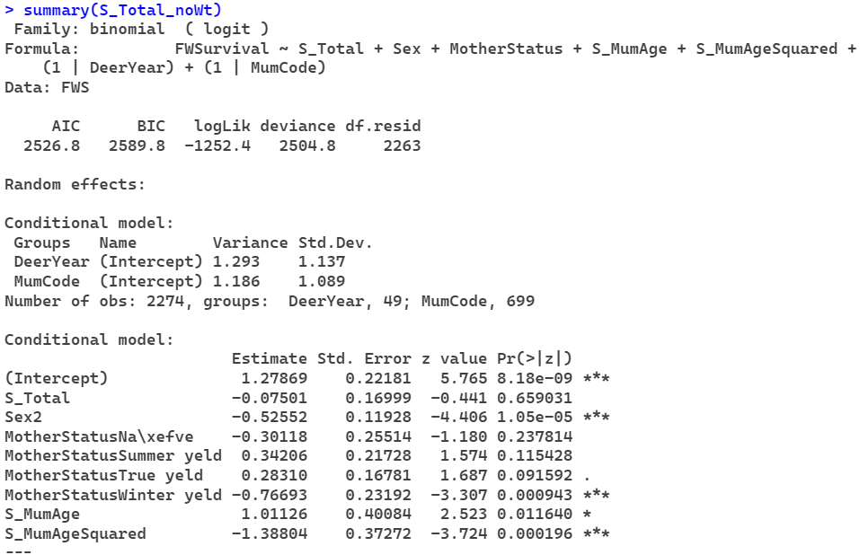

Livestock Units without Year & birth weight
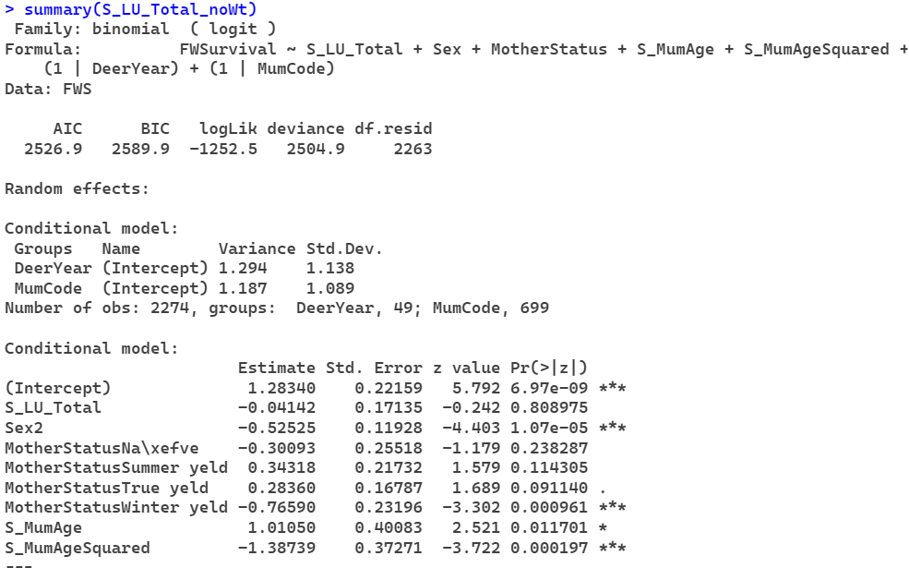

Spike
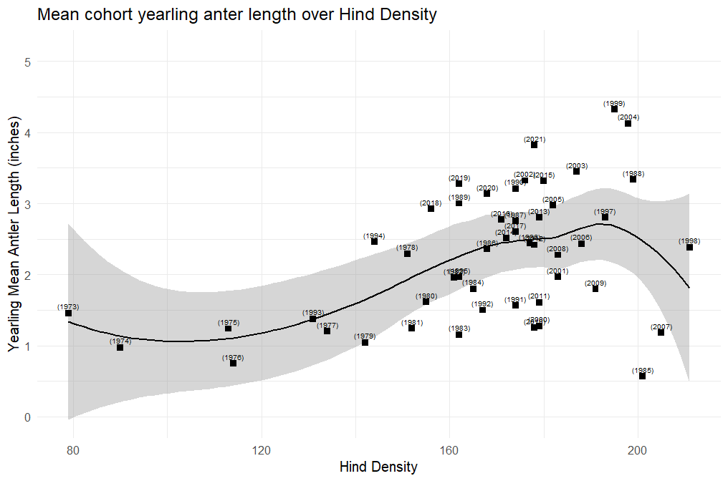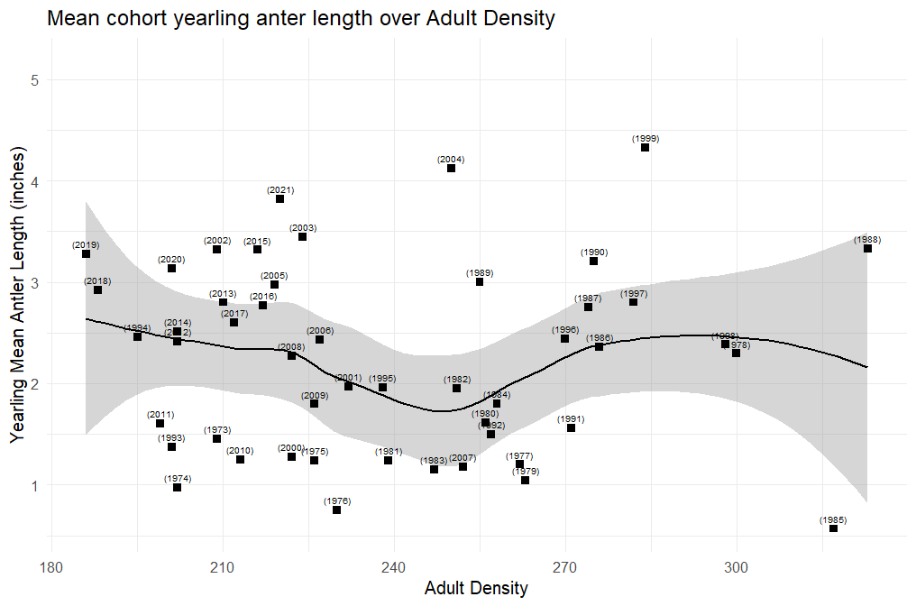
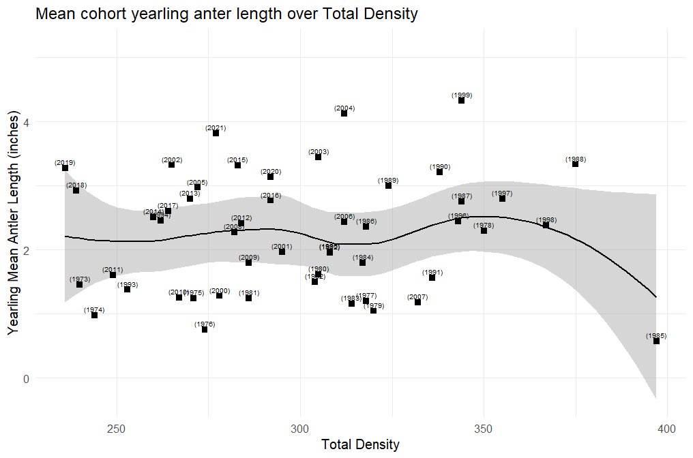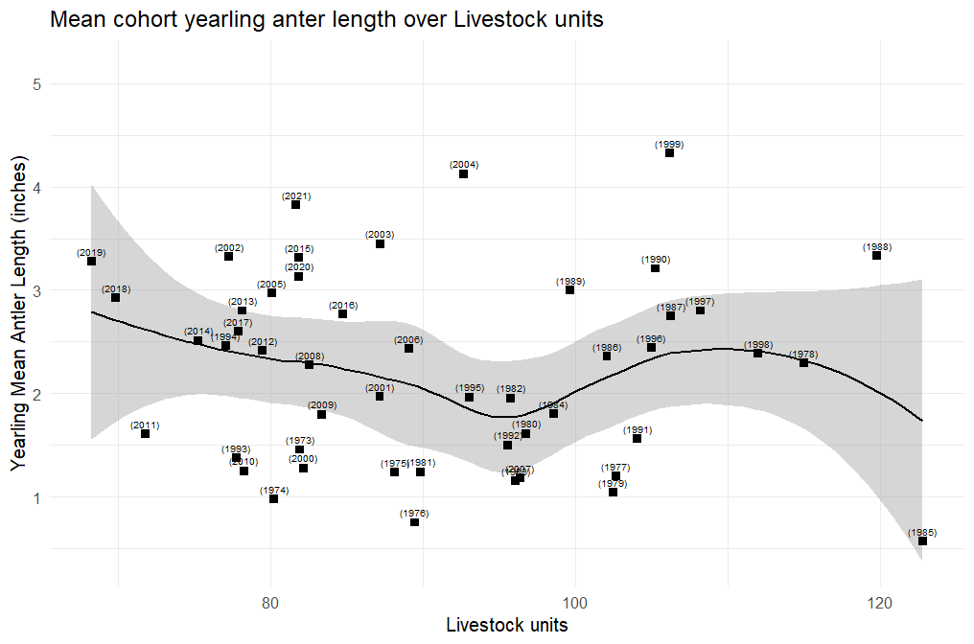

1972-2021 With Year as linear
Hinds
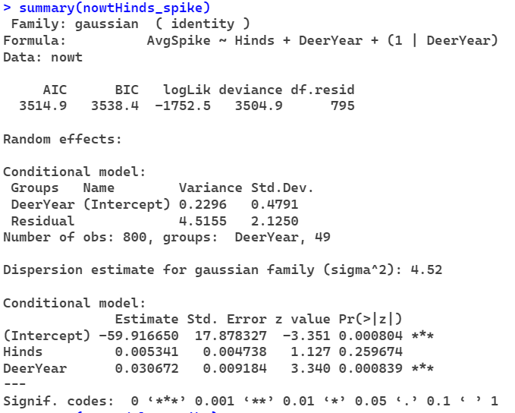
Adults
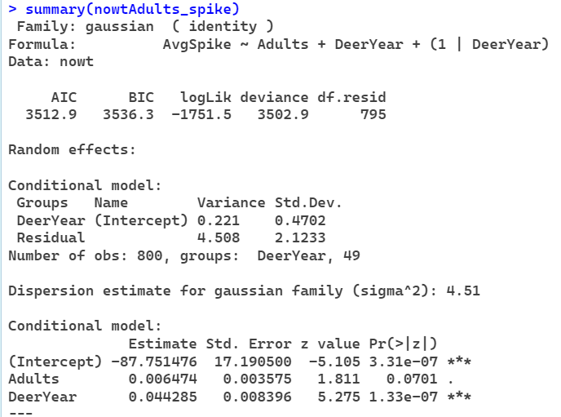

Total
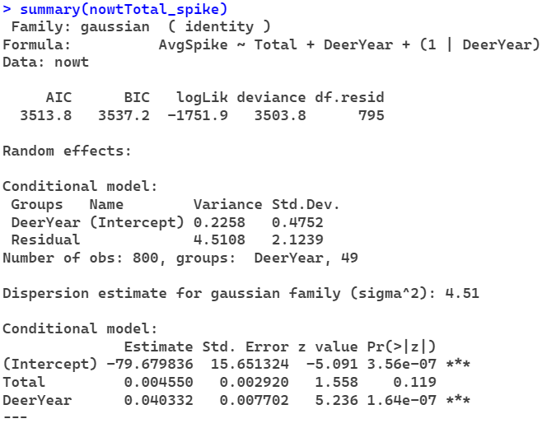
Livestock units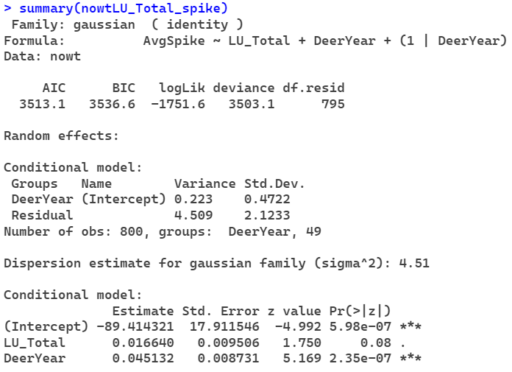

1973-1996 with year as linear
Hinds
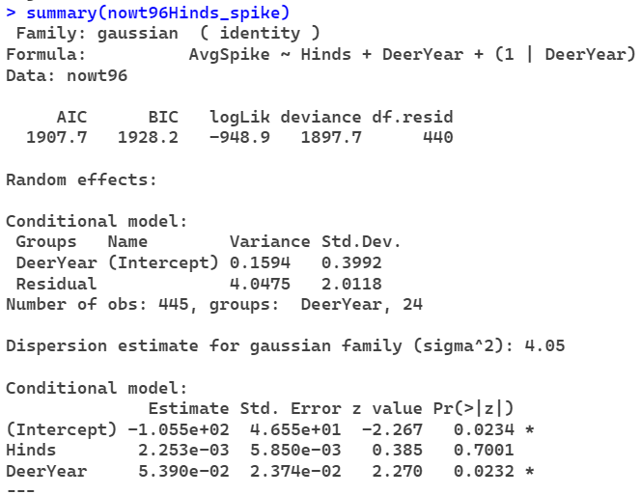
Adults
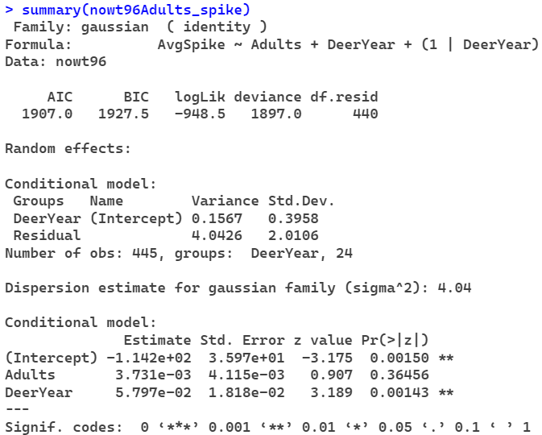
Total
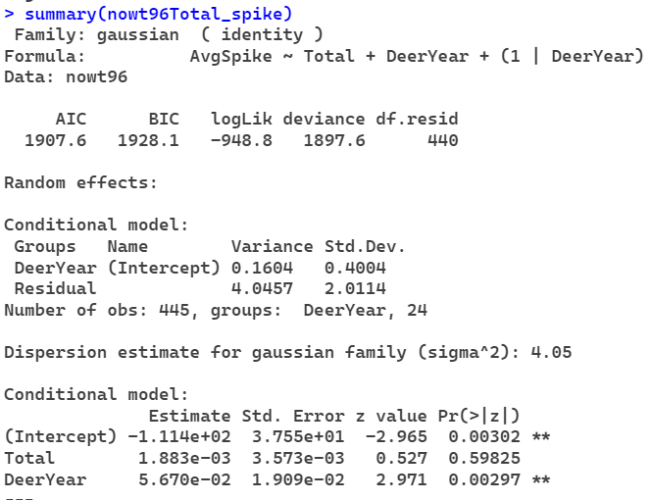
Livestock Units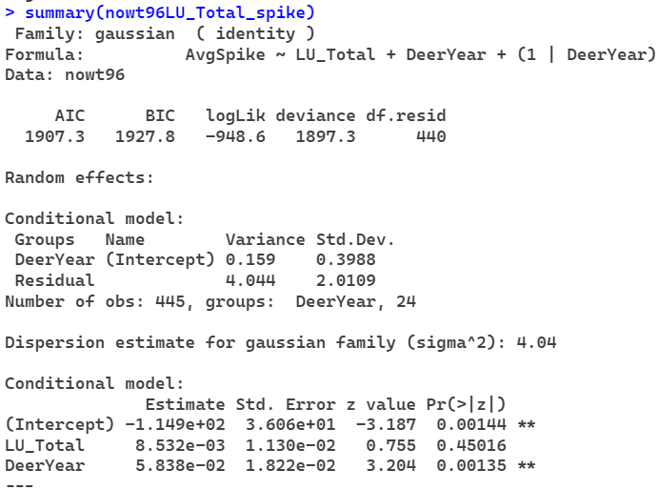

Using Birth Year 1973-2021
Hinds
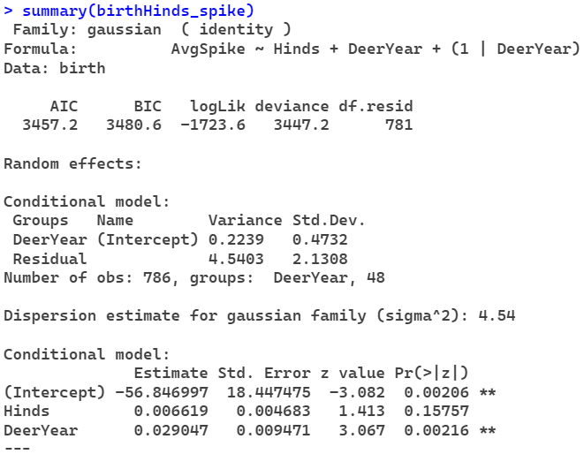
Adults
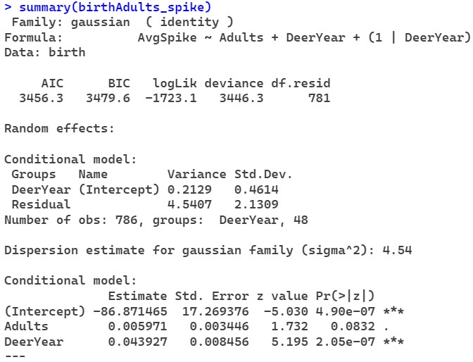

Total
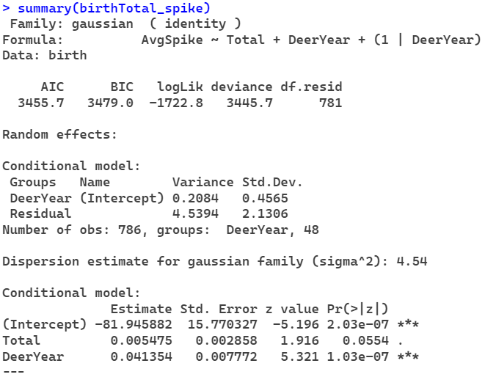
Livestock Units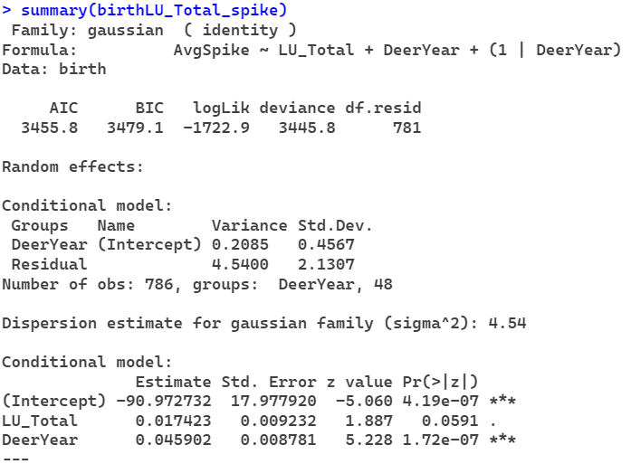
Using Birth Year 1973-1996
Hinds
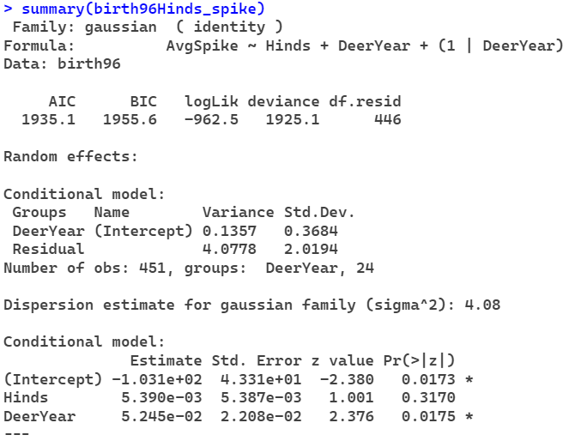
Adults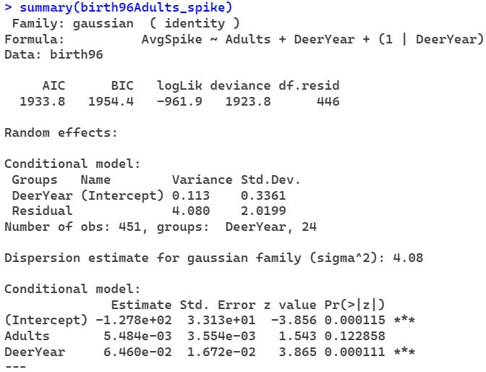
Total
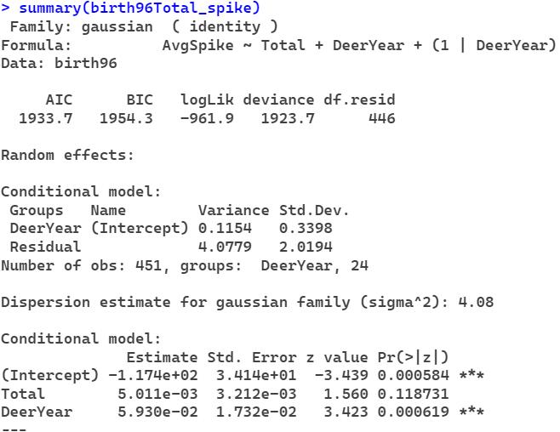
Livestock Units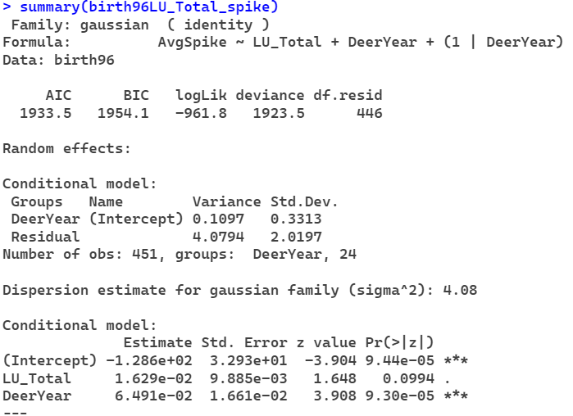

Observed Year without year as linear 1973-2021
Hinds
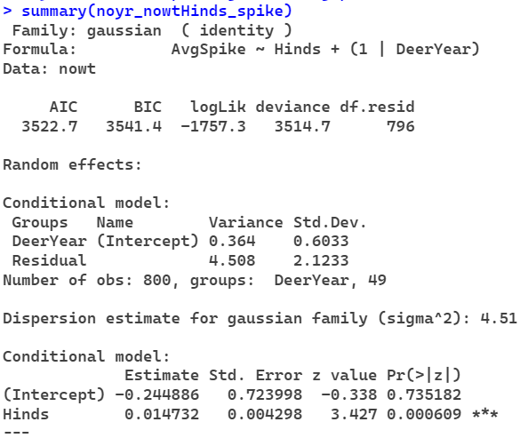
Adults
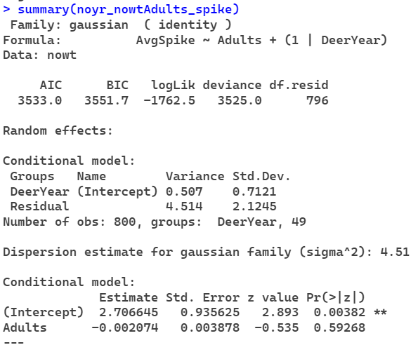

Total
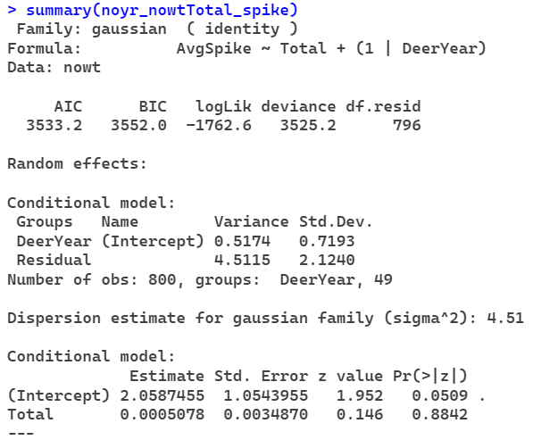
Livestock Units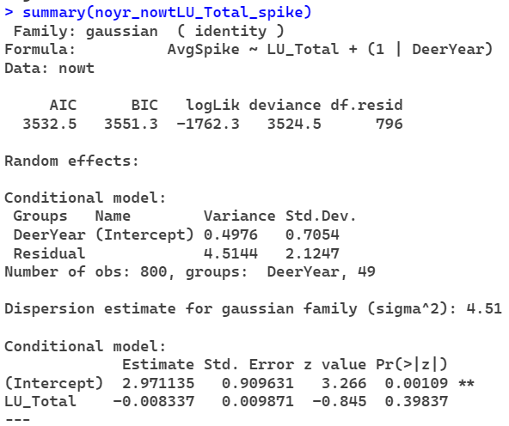

Observed Year without year as linear 1973-1996
Hinds
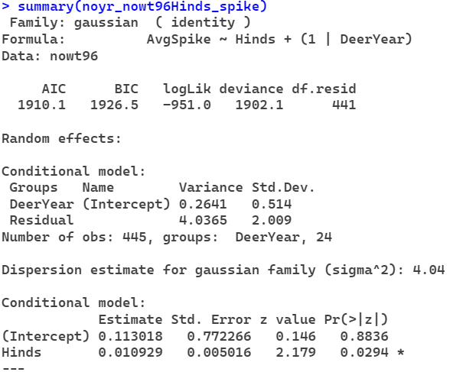
Adults
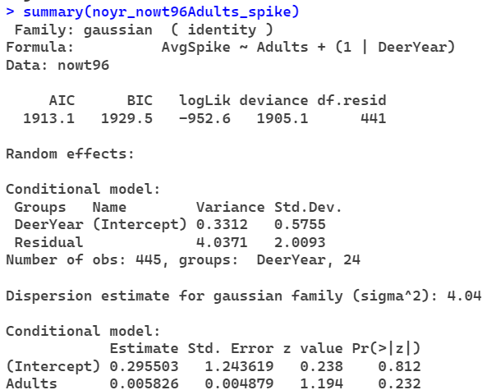

Total
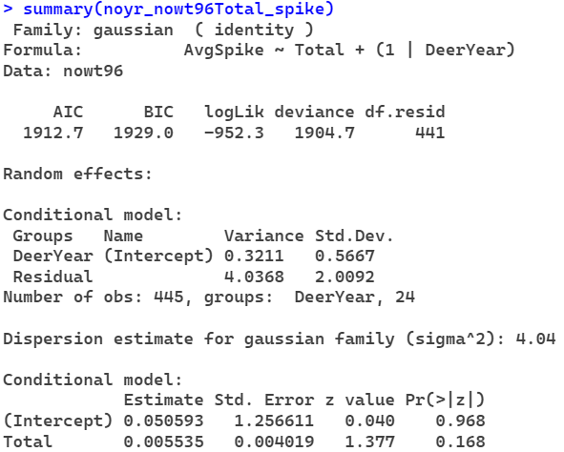
Livestock Units
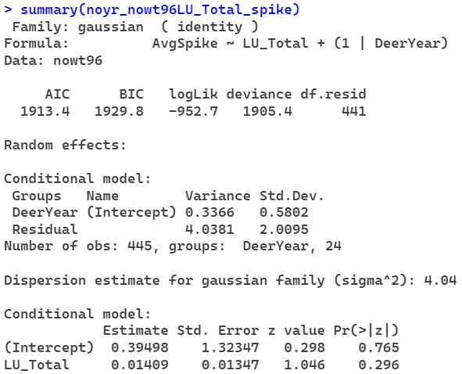

Birth Year without year as linear 1973-2021
Hinds
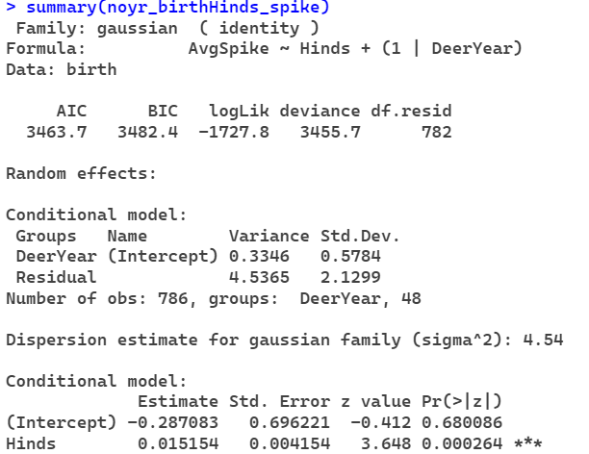
Adults
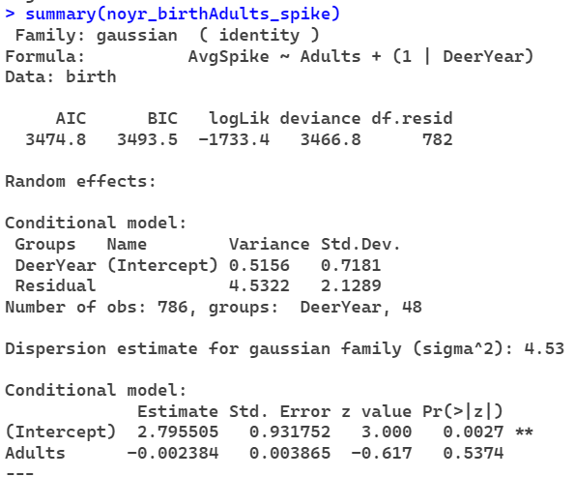
Total
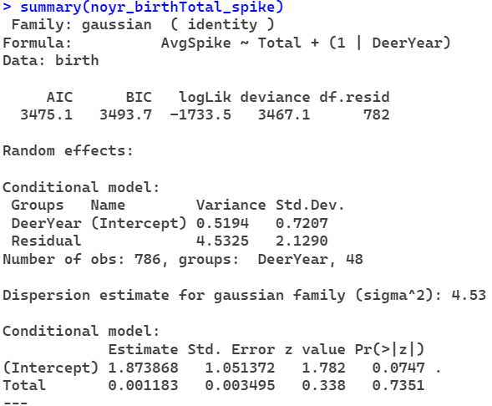
Livestock Units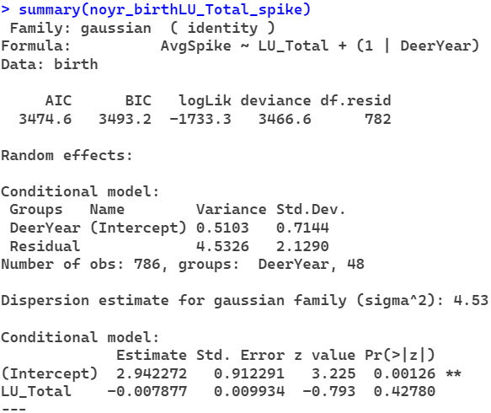
Birth Year without year as linear 1973-1996
Hinds
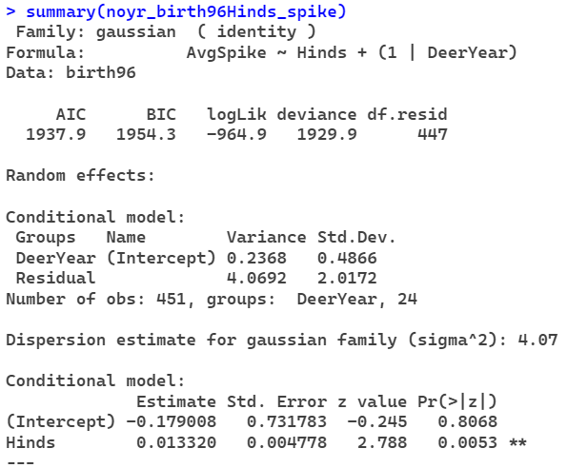
Adults
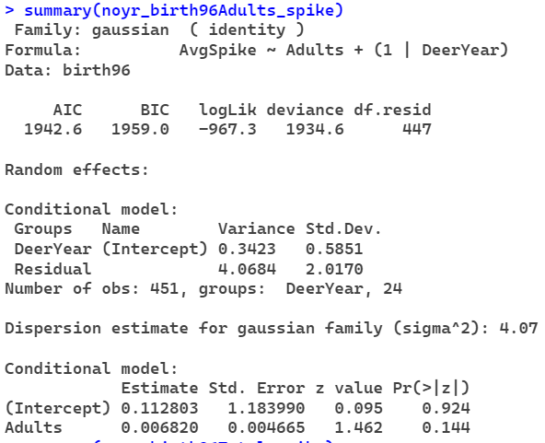
Total
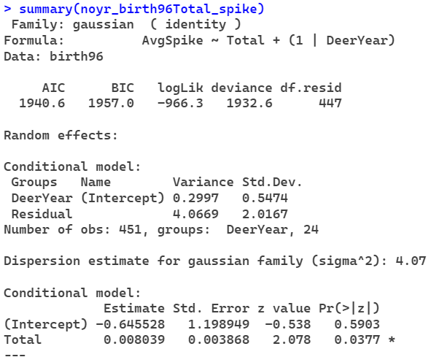
Livestock Units